CARDIOVASCULAR SCIENCES COLLABORATIVE PROGRAM
Faculty of Medicine, University of Toronto

ANNUAL REPORT
2009 – 2010

FitzGerald Bldg., 150 College Street, Room 88, Toronto ON M5S 3E2
Tel: 416/978-0746 Fax: 416/946-5713 E-mail: cv.program@utoronto.ca
Web site: www.cscp.utoronto.ca

CONTENTS

DIRECTOR’S MESSAGE……………………………………………………………………………….2

MISSION STATEMENT………………………………………………………………………………….4

COLLABORATING FACULTIES/UNITS/DEPARTMENTS………………..………………………..4

COMMITTEES…………………………………………………………………………………………….5
- Executive
- Program

COURSES OFFERED…………………………………………………………………………………...5

PROGRAM SPONSORED ACTIVITIES……………………………………………………………….6
- Annual Student Research Day
- Student Forum Night
- Cardiovascular Summer Initiative – CSI
- Circulation Rounds

AWARDS………………..……………………………………………………………………………….12
- Medtronic Travel Award
- Bigelow Book Prize
- Lorne Phenix Graduate Award
- Ontario Student Opportunity Trust Funds (OSOTF) Award
- Ontario Graduate Scholarships in Science and Technology (OGSST)

ADVERTISING MATERIAL…………………..…………………………………………………….….15

ACKNOWLEDGEMENTS…………..…………………………………………………………….……15

STUDENTS………………………………………………………………………………………………16
- Currently Enrolled
- Convocated/Follow-Up
- Awards and Honors
- Publications

FACULTY…………………..…………………………………………………………………………....23

DIRECTOR’S MESSAGE

Once again, it gives me great pleasure to provide this annual report highlighting the Cardiovascular Sciences Collaborative Program (CSCP) activities and accomplishments of our students and faculty over the 2009-2010 academic year. The ongoing financial support from the Heart & Stroke/Richard Lewar Centre of Excellence, Medtronic Canada and the Faculty of Medicine has allowed the CSCP to continue to serve the university community by enhancing the graduate student experience for all our member Departments and Faculties.
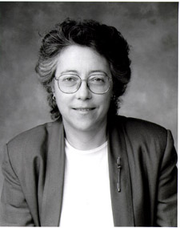

The CSCP had a sustained enrolment when compared to last year where it reached its highest ever (see graph below). Though we saw a small drop in the number of MSc students, there was an equal increase in the number of PhD students enrolled. Overall, we had a sustained total enrollment of 69 graduate students, even with 11 of our students successfully completing the Program. This is certainly a number we can be proud of and reflective of the value added the Program brings to the PhD training experience. This has even more impact when one considers they have to complete specific additional courses and program activity requirements. The level of student satisfaction with the Program continues to be confirmed during their annual meeting with the CSCP Student Affairs Committee Chair and the exit surveys they complete. Today’s discerning student is well aware that it is not enough to just fulfill their department’s degree requirements if they hope to succeed post graduation and compete for more and more limited postdoctoral or junior faculty positions. Even those who chose to enter professional degree programs, know that specialist certification, such as that which they obtain upon successful completion of the CSCP program, is a statement of excellence that provides them with an edge. The support of our faculty whose students participate in the CSCP must also be acknowledged and appreciated in the progressively more difficult financial times we face. Clearly any time taken from the research done by the student could be viewed as lessening the productivity for the supervisor, yet participation in CSCP is promoted. Clearly our faculty also value how the CSCP enriches the student and thereby increasing the quality of word and intellect that the student then contributeds to the research effort.

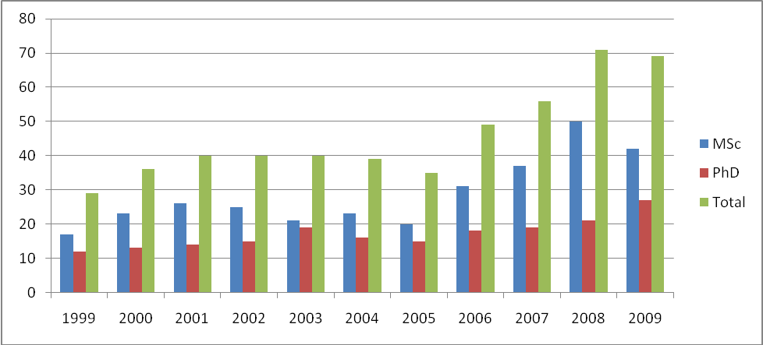

Discussions continued throughout this past year at the University of Waterloo on how the various interested departments and faculties there might interface with the CSCP and the University of Toronto. Though this has been in the works for years now, all key parties are eager to make this happen so we must exercise patience in the hopes that one day the combined program will become a reality.

There are many highlights related to CSCP activities through the year, the details of which can be found within the body of this annual report. The students certainly continue to value the day long Student Research Day where they are able to network with other students across the campus in the many differing disciplines. They learn from each other and creative collaborations are often another side benefit. This is continued during the regularly run Circulation Rounds which consist of visits to the research locations of our diverse faculty, both on and off campus. This allows the students to meet and experience current and ongoing projects in the cardiovascular arena in our diverse disciplines. The summer CSI series which has evolved to include practical visits to facilities such as the Toronto Rehabilitation Center and the University of Toronto Surgical Skills Laboratory, further expands the awareness of the breadth and depth offered at the University of Toronto in the cardiovascular sciences. Our flagship graduate course JCV3000 series, made up of the 4 modules, continues to be webcast with the live and archived seminars fully integrated and available to our students. This has facilitated the learning process to allow for more flexibility for the increasingly busy student schedules.

With the progress made over the past year, our objectives for 2010-2011 are to continue with the momentum established and to redouble our efforts in areas that have been slow to advance – as detailed below:

- Finalize the agreement and launch the joint initiative with the University of Waterloo
- Re-evaluate the curriculum and adapt or expand to more appropriately serve the current needs of knowledge translation in this area.
- Explore funding opportunities to establish stability for this award-winning program
- Maintain active student recruitment; identify areas for expansion
- Further develop CME programs in cardiovascular sciences

As you read through this report, it is evident that the CSCP does the extra to ensure that our trainee’s experiences at the University of Toronto are optimized and that our efforts dovetail with those of our participating departments to enhance both programs; making this the best place to come for graduate traing in this field. Specific details on all activities can be found on our web site at www.cscp.utoronto.ca. I would like to once again recognize the outstanding efforts of Victoria Simpson, our Business Officer, as well as the Executive Committee for their hard work and contributions that have made the Cardiovascular Sciences Collaborative Program the success it is today. And finally, I would like to take this opportunity to thank all our faculty and students for another successful year and to those individuals who have continued to provide both moral and tangible support for this Program.

Dr. Carin Wittnich, O.Ont.
Director, CSCP
Professor of Surgery & Physiology
Northrop Frye Scholar

MISSION STATEMENT

“The Cardiovascular Sciences Collaborative Program, approved by the University and Ontario Council on Graduate Studies in 1992, and listed in the calendar of the School of Graduate Studies, exists to give formal, organized expression to cardiovascular studies and research at the graduate level. It builds on the strengths of all participating academic units, and other agencies, to enhance the visibility of cardiovascular studies and to facilitate collaborative, interdisciplinary training and research.”

The above mission is achieved by advertising and promoting the importance of, and opportunities in, cardiovascular studies, by making known the results of such studies, by recruitment of excellent students, and by coordinating the graduate collaborative program in cooperation with the academic units in which they are registered. Students in this collaborative program must fulfill the requirements of their home units as well as the Program. Upon graduation the notation “Specialization in Cardiovascular Sciences” will appear on the student’s academic transcript and the Program will present the student with a certificate and gift.

COLLABORATING FACULTIES
Dentistry
Medicine
Nursing
Pharmacy
Physical Education and Health

COLLABORATING GRADUATE UNITS
Biomaterials and Biomedical Engineering
Dentistry
Exercise Sciences
Health Policy, Management & Evaluation
Laboratory Medicine and Pathobiology
Medical Biophysics
Medical Science
Nursing Science
Pharmaceutical Sciences
Pharmacology and Toxicology
Physiology
Public Health Sciences
Rehabilitation Science

SUPPORTING CLINICAL DEPARTMENTS
Anesthesia
Medicine
Surgery

COMMITTEES

Executive
The Executive Committee consists of 4 members of the Program Committee representing as wide a range of disciplines as possible and includes the Director. They also act as Chairs of the various subcommittees as noted beside their name. The Executive Committee provides student counseling, screens applicants, provides advice and acts as a Steering Committee.

Dr. C. Wittnich (Fundraising)
Dr. M. Rand (Scholarships & Awards)
Dr. V. Rao (Membership/Curriculum)
Dr. S. Thomas (Student Affairs)

Program
The Program Committee consists of a representative from each collaborating department as well as two student representatives. It administers the Program, selects the Director, and generally meets twice per year.

C. Wittnich (Chair)
D. Brooks (Rehabilitation Science)
S. Wu (Pharmaceutical Sciences)
D. Mazer (Anesthesia)
J. Parker (Pharmacology)
S. Heximer (Physiology)
D. Steinman (Institute of Biomaterials and Biomedical Engineering)
M. Rand (Laboratory Medicine and Pathobiology)
V. Rao (Institute of Medical Science)
TBA (Dentistry)
S. Thomas (Exercise Sciences)
TBA (Health Policy, Management and Evaluation)
S. Clarke (Nursing)
G. Wright (Medical Biophysics)
President, CSCP Student Association
Vice-President, CSCP Student Association

COURSES OFFERED

EXS5508H Cardiovascular Disease and Exercise
JCV1060H Developmental Cardiovascular Physiology
JCV3060H* Advanced Topics in Cardiovascular Sciences – Molecular Biology & Heart Signal Transduction
JCV3061H* Advanced Topics in Cardiovascular Sciences – Hormones
JCV3062H* Advanced Topics in Cardiovascular Sciences – Heart Function
JCV3063H* Advanced Topics in Cardiovascular Sciences – Vascular
JEB1365H Ultrasound: Theory and Applications in Biology and Medicine
JTC1331H Biomaterials Science
LMP1015H Vascular Pathobiology
LMP1504H Cell and Molecular Biology of Cardiovascular Diseases
PSL1462H Molecular Aspects of Cardiac Function
* Core Courses for PhD Trainees (2 of 4 modules required); JCV denotes joint listing with most of our collaborating departments.

Suggested Courses (Considered valuable but does not fulfill Program requirements)
CHL5201 Introducing Biostatistics for Students in Biological Sciences
LMP1404S Cellular and Molecular Mechanisms of Disease
PSL1052H Fundamentals on Ion Channel Function

PROGRAM SPONSORED ACTIVITIES

ANNUAL STUDENT RESEARCH DAY
The 11th Annual Student Research Day was held on Wednesday, February 17, 2010. CSCP students were given the opportunity to present their research to their peers in a welcoming environment promoting discussion and the free flowing of ideas. The day began with opening remarks from the CSCP Director, Dr. Carin Wittnich, followed by a day of excellent science presented by our students and inspiring presentations from our guest speakers. Awards were also presented to outstanding students and certificates presented to students who had completed their CSCP training.

Student Presentations
As part of the CSCP requirements, all students must present their research during their training period. This presentation is 10-minutes followed by a brief question period. Presentations cover a broad range of cardiovascular research topics. Session Chairs are provided by the previous year’s Bigelow Book Prize recipient and the Lorne Phenix Graduate Award recipient.

Session I: Chair – Jane MacIver
Albert Tsui (PhD – Department of Physiology)
Methemoglobin as a potential biomarker in anemic stress: Role of neuronal nitric oxide synthase
June Guo (MSc – Department of Physiology)
Role of SIRT1 in the effect of resveratrol to decrease neointimal growth after arterial injury
Matthew Machina (MSc – Department of Physiology)
Continuous positive airway pressure in a gas mask, with reduced lung compliance and in exercise
Phil Xue (MSc – Institute of Medical Science)
Human MSC differentiation toward myogenic phenotype in 3D clusters
Amir Manbachi (MSc – Department of Biomedical Engineering)
Characterization of carotid artery geometry and its impact on blood-flow velocity profiles
Kaveesh Dissanayake (MSc – Department of Physiology)
Defining the mechanisms which regulate the localization and function of RGS4
Sanjana Sen (MSc – Department of Laboratory Medicine and Pathobiology)
Retinoblastoma protein: The link between elastogenesis and proliferation.
Anna Rosen (MSc – Department of Physiology)
Electrical conduction through the His-Purkinje system of the heart
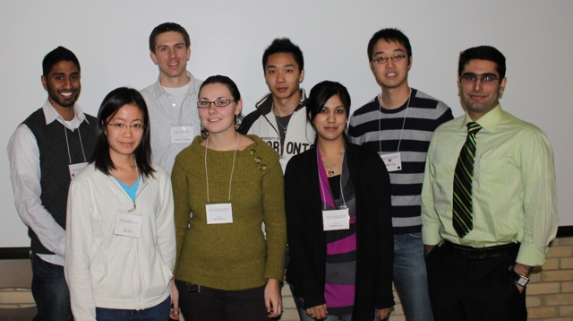
(Front Row: June Guo, Anna Rosen, Sanjana Sen, Amir Manbachi. Back Row: Kaveesh Dissanayake, Matthew Machina, Phil Xue, Albert Tsui)

Session II: Chair – Luke Tan
Junyan Shi (MSc – Institute of Medical Science)
Insulin promotes elastin production in cultured human aorta smooth muscle cells
Andrew Ramadeen (PhD – Department of Pharmacology)
n-3 Polyunsaturated fatty acid prophylaxis reduces vulnerability to atrial fibrillation
Leanna Lee (MSc – Department of Exercise Sciences)
Assessment of left ventricular torsion/recoil in young, middle-age, and endurance-trained men
Melissa Noronha (MSc – Department of Physiology)
Identification and characterization of cell-surface associated proteins of the human heart
Sam Liu (MSc – Department of Exercise Sciences)
Relationship between post-exercise hypotension and blood pressure response to chronic training
Mostafa El-Beheiry (MSc - Department of Physiology)
Acute β-blockade impairs mouse mesenteric and cerebral resistance artery vasodilation in vitro
Jemy Joseph (MSc – Institute of Medical Science)
Everolimus is associated with soluble human leukocyte antigen-G expression in heart transplants
Olena Puzyeyeva (MSc – Institute of Medical Science)
Conjunctival blood oxygen saturation in healthy individuals
Alex Di Battista (MSc – Department of Exercise Sciences)
The effects of extracellular heat shock protein 70 on cardiovascular function and inflammation

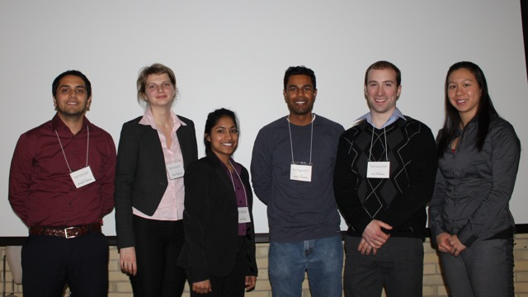
(L-R: Mostafa El-Beheiry, Olena Puzyeyeva, Jemy Joseph, Andrew Ramadeen, Alex Di Battista, Leanna Lee. Absent: Junyan Shi, Melissa Noronha, Sam Liu)

Awards/Certificates
Dr. Wittnich presented certificates to students who successfully completed the Cardiovascular Sciences Collaborative Program over the past year:

Eser Adiguzel, PhD/LMP, Supervisor: Dr. M. Bendeck
Laura Banks, MSc/EXS, Supervisor: Dr. J. Goodman
Nazanin Hakimzadeh, MASc/BME, Supervisor: Dr. D. Courtman
Melanie Henriques, MSc/PSL, Supervisor: Dr. H. Zhang
Shathiyah Kulandavelu, PhD/PSL, Supervisor: Dr. L. Adamson
Mark Moon, MSc/PSL, Supervisor: Dr. P. Liu
Mark Ormiston, PhD/BME, Supervisor: Dr. D. Courtman
Kumar Perampaladas, MSc/PCL, Supervisor: Dr. J. Parker
Meghan Sauvé, MSc/IMS, Supervisor: Dr. D. Drucker
Michael Sellan, MSc/PSL, Supervisor: Dr. P. Backx
Stjepan Soric, MSc/PSL, Supervisor: Dr. C. Wittnich
Carly Spragg, MSc/EXS, Supervisor: Dr. S. Thomas
Luka Srejic, MSc/PSL, Supervisor: Dr. Wm. Hutchison
Sam Tirgari, MSc/PSL, Supervisor: Dr. S. Heximer
Laura Voicu, MSc/PSL, Supervisors: Drs. D. Mazer/G. Hare
Michael R. Ward, PhD/IMS, Supervisor: Dr. D. Stewart

Continuing with the spirit of success and achievement, the annual CSCP student awards were presented by Dr. Margaret Rand, Chair, CSCP Awards and Scholarships Subcommittee.

2010 Bigelow Book Prize Recipient – Carlo Cifelli
The CSCP congratulates Mr. Carlo Cifelli, a PhD candidate in the Department of Physiology, supervised by Dr. S. Heximer, who was presented with the 2010 Bigelow Book Prize for his continued and sustained academic scientific excellence. Carlo studies the role of the regulator of g-protein signaling 4 (RGS4) in the atria of the heart. He has discovered that RGS4 is integral in protecting the heart from atrial fibrillation, which is a major contributor to heart disease. Carlo was presented his award by Dr. Bigelow’s daughter, Mrs. Pixie Currie and Dr. Rand.

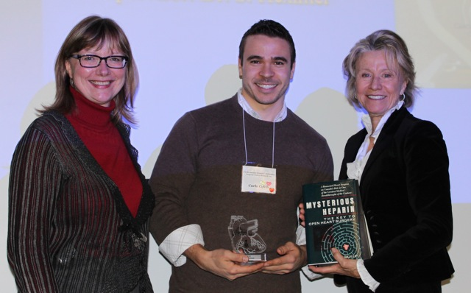
L-R: Dr. Margaret Rand, Carlo Cifelli, and Mrs. Pixie Currie

2009-2010 Lorne Phenix Graduate Award Recipient – Amir Manbachi
The CSCP congratulates Mr. Amir Manbachi, an MASc candidate at the Institute of Biomaterials and Biomedical Engineering, supervised by Dr. D. Steiman, who was presented with the Lorne Phenix Graduate Award. Amir’s work on blood-flow velocity profiles in the common carotid artery have direct implications in giving insight towards the pathogenesis of atherosclerosis and other vascular contributions towards heart disease. Amir’s award was presented by Ms. Kathryn Phenix, daughter of Mrs. Geraldine Phenix, whose generous donation founded the award, and by Dr. Rand.

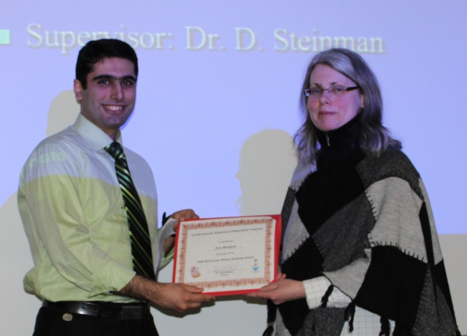
L-R: Amir Manbachi and Ms. Kathryn Phenix

Following the awards presentations, students socialized and networked during lunch before being treated to our guest speakers for the day.

Guest Speakers
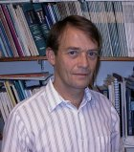
Dr. Richard Hughson, Professor of Kinesiology and Graduate Associate Dean at the University of Waterloo, was one of our visiting guest speakers. He spoke to the students of his academic journey from keen undergraduate student to where he is today. Along the way he discussed his research milestones, culminating with his current work in assessing the changes to the cardiovascular system of astronauts caused by extended periods in zero-gravity.

Dr. Steffen-Sebastian Bolz, Associate Professor of Physiology here at the University of Toronto also joined us this year. Being a product of the German academic system and recently making the move to Canada and the University of Toronto, Dr. Bolz was able to give students insight into the challenges of going abroad and changing countries for training or to pursue career opportunities. Themes that Dr. Bolz explored were how none of his most significant career decisions were planned and the importance of staying grounded with a life outside of the lab.

The CSCP sends our deepest thanks to our guest speakers this year for the very insightful and interesting talks which will no doubt resonate strongly with us for the rest of our careers.

Session Presentation Award Winners
As the CSCP Student Research Day entered into its second decade of existence, the organizing committee introduced student presentation awards to the top student in each session. Each presenter was evaluated by three of their peers and a composite score was calculated to determine the best presentation in each session. Criteria included content (quality of research, organization of presentation), visuals (clarity, readability), delivery (voice level, pacing) and overall impression. Congratulations to both winners for their excellent talks.

Session I Winner:
Anna Rosen – Electrical conduction through the His-Purkinje system of the heart

Session II Winner:
Andrew Ramadeen – n-3 Polyunsaturated fatty acid prophylaxis reduces vulnerability to atrial fibrillation

Closing
The Student Research Day was a success and would not have been possible without the combined efforts of several individuals. The Research Day Co-Chairs (Victoria Simpson and Mostafa El-Beheiry) would like to thank Albert Tsui, and Namhee Kim for helping out with various tasks throughout the day, Drs. Hughson and Bolz for outstanding and inspiring presentations, and our Session Chairs, Jane McIver and Luke Tan for keeping the day running smoothly. Thank you to all our students and to all involved in making the 11th Annual CSCP Student Research Day a great success.

STUDENT FORUM
This event is an excellent opportunity for new students of the CSCP to meet one another and for senior students to catch up with old friends, and develop relationships with the up and comers. Discussions range from basic research, laboratory trials and triumphs, to future academic /career directions. Connections for research collaboration, as well as friendships are developed, and all those in attendance thoroughly enjoy the festive dinner and the change to meet other students. Due to a lack of funding we were unable to provide the CSCP student body with the 2009 CSCP Forum and dinner. We hope to resume this event in 2010.

CARDIOVASCULAR SUMMER INITIATIVE (CSI) 2010
Congratulations to the Program Committee (Geoffrey de Couto, Sonya Hui, Anton Mihic) on their successfully organized and run Cardiovascular Summer Initiative (CSI). The series was targeted at undergraduate students involved in cardiovascular summer research and aimed to give students a comprehensive view of all aspects of research by incorporating basic, translational and clinical information. CSI 2010 ran for two hours on Fridays from July 23rd to August 13th beginning at 10am. Altogether 11 students signed up for the Cardiovascular Summer Initiative with great student representation from research hospitals around the Toronto area (TGH, TWH, Sunnybrook).

The CSI began with an orientation session that outlined the events scheduled over the course of the summer as well as the role of the CSCP. Two speakers were present, Geoffrey de Couto, as well as our guest speaker from Dr. Ren-Ke Li’s Lab, post-doctoral fellow Dr. Keith Brunt. Together, both speakers provided a brief powerpoint presentation and followed up with a group discussion on cardiovascular research from bench to bedside.

The second event was a lab tour of the exercise physiology lab of Dr. Scott Thomas at the Athletic Centre, University of Toronto. At this session, Dr. Thomas along with his Master’s student Sam Liu, demonstrated functional measurements of exercise physiology. Testing of VO2max, a common measurement used to assess lung function and capacity at maximal exertion was demonstrated with volunteer Geoffrey de Couto. This demonstration involved use of a heart rate monitor, a head strap with exhaust to capture CO2 release and a treadmill. The subject ran for 20 minutes and provided real time feedback on his level of exertion. All students present fully enjoyed the demonstration and discussion period.

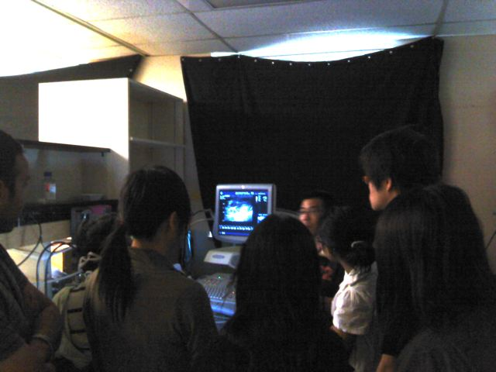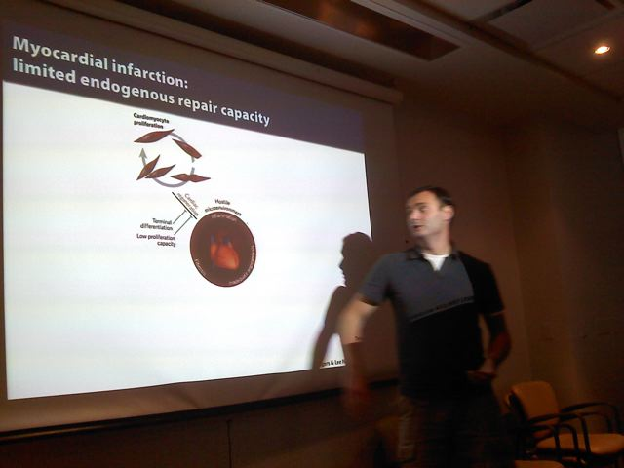The third event was a tour targeted at modeling disease. There was a presentation and discussion by CSCP students describing the current state of regenerative medicine and stem cell research in Toronto (what they are, what they can do (benefits and pitfalls), how/where they have been applied in cardiovascular research) and the clinical applications of this innovative tool – clinical trials, etc. This event also included tours of the MaRS Animal Resource Centre (ARC), the large animal surgical suites, and the STARR imaging facility. As well as a demonstration of functional cardiac measurements using echocardiography in rats in Dr. Ren Ke Li’s lab.

The final event was a campus-wide photohunt. Representatives from six cardiovascular laboratories were integrated into the hunt:
- Dr. Steffan-Sebastian Bolz
- Dr. Peter Backx (representative – Sonja)
- Dr. Anthony Gramolini (representative – Tim Ryan)
- Dr. Doug Lee (representative – Shaan Chugh)
- Dr. Peter Liu (representative – Phil Wood)
- Dr. Ren Ke Li (representative – Dr. Keith Brunt)

Students were paired and given maps and contacts for the lab representatives. The goal was to reach each lab, listen to a description of the lab from the representative, and upon completion, take a picture with that representative. The team who reached all labs with a photo and returned to the MaRS fastest was ranked and quizzed on the information from each lab. This session was the most successful of all – each student thoroughly enjoyed the activity.

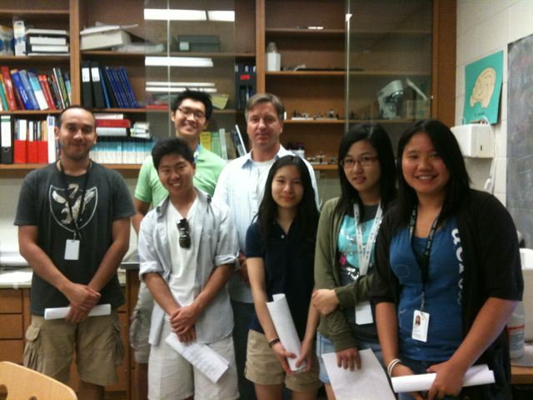
Photohunt CSI 2010: (Back Row) Jong Park, Dr. Steffan-Sebastian Bolz
(Front Row) Wesam Tulba, Trevor, Meghan Chan, Annie Chan, Jessica Ngan

The overall impression of the summer CSI program was very good. It provided an enjoyable learning environment and an opportunity to interact with students outside of their own environment. Each session was informative and well received.

CIRCULATION ROUNDS
The CSCP student body organizes and runs this event which highlights the diverse nature of research carried out by our faculty. These academic rounds rotate through the various research sites at the University of Toronto and each event is hosted by a faculty member where their research focus is the topic of the day. The goal of this event is to provide graduate students, post-doctoral fellows, research associates, undergraduates and project/summer students with the chance to develop an appreciation of the vast range of excellent research being conducted in our widespread community. The students do a great job organizing these events and all seminars are well attended. For more detailed information regarding the presentations noted below, please go to the CSCP web site at www.cscp.utoronto.ca.

Presenter | Date and Time | Location | Topic
Dr. Lee Adamson | Thurs. Nov 26th, 2009; 3pm | Lunenfield Institute  (3rd floor Rm.201-203) | Using mice as models for studying CV function, and dysfunction, in pregnancy
Dr. Greg Hare | Tuesday Jan 26th, 2010; 2pm | St. Michael’s Hospital (rm. TBA) | Beta-adrenergic Antagonism Post-Hemodilution
Dr. Richard Weisel | Thursday, Mar 4th, 2010; 2pm | TGH  Rm. 1N-130 | Cardiac regeneration by cell transplantation
Dr. Phil Marsden | Tuesday April 6th, 2010; 2 pm | MSB  Rm. 3163 | Regulation of gene expression in the  cardiovascular system - a role for epigenetics
Dr. Seema Mital | Thursday May 20th, 2010; 2pm | Sick Kids  Rm. 4132 | Genomics of heart disease

AWARDS

MEDTRONIC TRAVEL AWARD
Two competitions were held (spring and fall) for the Medtronic Travel Award. This award, established in 1995, helps to defray costs of travel for Program students presenting their research work at recognized scientific meetings. Students supported by this award this academic year were:

Fall 2009:
Geoffrey de Couto, PhD, Department of Physiology (Supervisor: Dr. P. Liu)
Canadian Cardiovascular Society Annual Meeting, Alberta, 2009
“Innate Immune Transcription Activator Interferon Regulatory Factor-3 (IRF-3) Coordinates Post-Infarction Repair but Contributes to Adverse Remodelling”

Laura Banks, MSc, Department of Exercise Sciences (Supervisor: Dr. J. Goodman)
Canadian Society for Exercise Physiology Annual Meeting, British Columbia, 2009
“Left and Right Ventricular Function Following Prolonged Exercise in Young, Trained Athletes: Influence of Exercise Intensity”

Sam Liu, MSc, Department of Exercise Sciences (Supervisor: Dr. S. Thomas)
Canadian Society for Exercise Physiology Annual Meeting, British Columbia, 2009
“Post Exercise Hypotension After Prolonged Exercise in Young and Old Individuals”

Spring 2010:
June Gui, PhD, Department of Physiology (Supervisor: Dr. A. Giacca)
American Diabetes Association Annual Meeting, Orlando, Florida, 2010
“Role of SIRT1 in the Effect of Resveratrol to Decrease Neointimal Growth After Arterial Injury”

Namhee Kim, MSc, Department of Physiology (Supervisor: Dr. D. Mazer)
Asian Pacific Congress of Nephrology Conference, Seoul, Korea, 2010
“Transient, Large Water Diuresis Following Exposure to a Modest Degree of Hypoxia; Prevention with DDAVP”

BIGELOW BOOK PRIZE
This prize was established in 1995 by the Cardiovascular Sciences Collaborative Program to recognize and honor a pioneer clinician and scientist in the field of cardiovascular sciences. Awardees should exemplify the personal traits of Dr. Bigelow - curiosity, drive, and scientific integrity. The award is given in every year that a qualified student is identified. Qualifications include sustained academic scientific excellence, innovative experimental approaches, original discoveries and good scientific productivity. Some weight is given to work that has recognizable clinical relevance, especially that which promises to improve patient care. The Bigelow Book Prize consists of 2 books written by Dr. W.G. Bigelow entitled “Cold Hearts” and “Mysterious Heparin” and a keeper plaque created to honor Dr. Bigelow. Appropriate candidates are identified and the final decision is made by the Program Committee.

1995 – John S. Ikonomidis 2003 – Paul W.M. Fedak
1996 – Shona M. Torrance 2004 – Nathalie Lapointe
1997 – Vivek Rao 2005 – Karim Bandali
1998 – Bryce Cowan 2006 – Danny Ramzy
1999 – Gideon Cohen 2007 – Patricia Rose
2000 – Michael Borger 2008 – Mitesh Badiwala
2001 – Saeid Babaei 2009 – Jane MacIver
2002 – Wm. Jack Wallan 2010 – Carlo Cifelli

(L-R): Dr. Margaret Rand, (Chair, Awards Subcommittee), Carlo Cifelli, Mrs. Pixie Currie (Dr. Bigelow’s daughter)

Carlo Cifelli, is a Doctoral student in the Department of Physiology under the Supervision of Dr. Scott Heximer. His doctoral research is on the role of the Regulator of G-protein Signaling 4 (RGS4) in the heart, but more specifically the atria. Initial findings showed that RGS4 is highly expressed in the sinoatrial node, is involved in its parasympathetic regulation, and is thus an important regulator of heart rate. More recently, we showed that RGS4 is involved in protecting the heart against atrial fibrillation, a major contributor of heart disease. Although our main findings have been on the murine model, we have shown changes in RGS4 expression in a tachypaced canine model as well, and hope to study human patients with atrial fibrillation in the future. It may be that our studies will unearth a novel therapeutic treatment and prevention strategies for atrial fibrillation, with RGS4 as the primary target.

LORNE PHENIX GRADUATE AWARD
This award was made possible by a generous donation in the memory of Mr. Lorne Phenix by Mrs. Geraldine Phenix. It is her hope that this award will focus attention on the issue of heart disease – which is still the #1 killer of both men and women in Canada. In addition, women who have heart problems are at least equal if not at greater risk than men and Mrs. Phenix hopes that this award will serve to encourage trainees to pursue this area of research to address this particular problem. It is awarded to a graduate student in the Faculty of Medicine on the basis of research and academic excellence. The award consists of a cash prize and certificate and is presented to the recipient at the Annual Student Research Day. Appropriate candidates are identified and a winner is selected by a subcommittee chaired by Dr. Donna Stewart. This award is presented at the Annual Student Research Day.

2001 – Wm. Jack Wallen 2006 – Danny Quaglietta
2002 – Wm. Jack Wallen 2007 – Emma O’Donnell
2003 – Shathiyah Kulandavelu 2008 – Luke Tan
2004 – Rachel Mitchell 2009 – Amir Manbachi
2005 – Nesime Askin
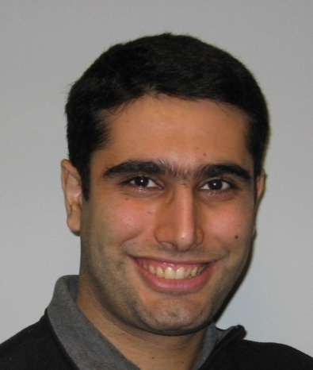
Amir Manbachi is a MASc candidate at the Institute of Biomaterials and Biomedical Engineering, under the supervision of Dr. David Steinman.

The carotid artery bifurcation in the neck is a region prone to the development of atherosclerotic plaques, the rupture of which can lead to stroke. Plaques are thought to occur here due to the complex flow patterns influenced by the geometry of vessels in this region. Most clinical studies typically assume that Common Carotid Artery (CCA), proximal to the bifurcation, is relatively straight enough to consider a symmetric distribution of blood velocities across the lumen. However a recent study has shown the presence, in vivo, of velocity profiles strongly skewed to one side of the lumen for mildly curved CCAs. In Amir's thesis, the objective is to identify geometric parameters that can be used to quantify CCA shape and to determine whether those parameters are correlated with, or at least can anticipate, the degree of velocity profile skewing.

Aside from giving insight about atherogenesis, it is hoped that the extension of this work will ultimately lead to guidelines for anticipating, and possibly compensating for, skewed velocity profiles in studies of blood flow in mildly curved arteries, such as Doppler ultrasound measurements of blood flow; or the design of vascular bypass grafts, where velocity profile skewing has recently been shown to improve long-term patency.

ONTARIO STUDENT OPPORTUNITY TRUST FUNDS (OSOTF) AWARD
The OSOTF award refers to a class of awards that have resulted from the Ontario government’s “matching” program. Under the program every dollar of donation received for student assistance has been matched by the government as well as the university on a dollar-for-dollar basis. The Cardiovascular Sciences Collaborative Program participates in this program. There are two major conditions for all OSOTF awards; recipients must be Ontario residents and demonstrate financial need. However, the Program has additional eligibility criteria that must be adhered to, including excellence in science and academic performance. One competition is held per academic year. The applications are handled centrally through the Office of the Associate Dean, Inter-Faculty and Graduate Affairs. Applications pertaining to the CSCP are sent to us and are then adjudicated by a subcommittee chaired by Dr. Margaret Rand. Committee recommendations are then forwarded to the OSOTF Awards Committee (Faculty of Medicine). No applications were received for the 2009-2010 competition.

ONTARIO GRADUATE SCHOOL SCIENCE & TECHNOLOGY (OGSST)
The OGSST program is designed to encourage excellence in graduate studies in science and technology. The program is supported through funds provided by the Ministry of Training, Colleges and Universities and by funds raised by the University of Toronto and the Heart & Stroke Foundation of Ontario. To be awarded to graduate students at the University of Toronto who are pursuing cardiovascular/stroke research. Students must have maintained an overall A- average over the last two years of study at the post-secondary level and exhibit research ability/potential, good communication skills and interpersonal/leadership abilities. The following students were ranked and offered an award:

Name Degree Dept. Supervisor
June Guo MSc PSL A. Giacca
Junyan Shi MSc IMS A. Hinek
Robin Lao MSc IMM R. Yeung
K-H Kim PhD PSL P. Backx
Devanghai Odedra MSc CHE M. Radisic
A. Nahirny PSc PSL L. Mills
H. Flowers PhD SLP R. Martino
S. Molfenter PhD SLP C. Steele

ADVERTISING MATERIAL

The CSCP maintains and updates its web site (www.cscp.utoronto.ca). Faculty information is updated whenever we are notified of relevant changes. Collaborating departments are encouraged to provide hypertext links to the CSCP on their web site.

ACKNOWLEDGEMENTS

The Cardiovascular Sciences Collaborative Program would like to thank the following sponsors for their generous support: Medtronic Canada, the Heart and Stroke/Richard Lewar Centre of Excellence and the Faculty of Medicine.

STUDENTS

Name Supervisor Degree Department
Jenna Adleman C. Hudson MSc IMS
Katherine Allan P. Dorian PhD IMS
Nesime Askin C. Wittnich PhD PSL (inactive status)
Mitesh Badiwala V. Rao PhD IMS
Laura Banks B. McCrindle PhD IMS
Payam Bahman-Bijari D. Steinman PhD BME
Mark Blaser C. Simmons PhD BME
Roxy Chis A. Gramolini MSc PSL
Carlo Cifelli S. Heximer PhD PSL
Geoff de Couto P. Liu MSc PSL
Alex Di Battista M. Locke MSc EXS
Kaveesh Dissanayake S. Heximer MSc PSL
Mostafa El Beheiry G. Hare MSc PSL
Sam Esfandiari J. Goodman MSc EXS
Talha Farid K. Nanthakumar MSc IMS
Joe Gabriel D. Bradley MSc IMS
Arash Ghashghai V. Rao MSc IMS
June (Hui Jun) Guo A. Giacca MSc PSL
Christy Hamilton M. Locke MSc EXS (inactive status)
Sonya Hui M. Husain MSc PSL
Jemy Joseph V. Rao MSc IMS
Jalil Kalantari H. Ni MSc PSL
Shazareen Khan S. Thomas MSc EXS
Namhee Kim D. Mazer MSc PSL
Jeffrey Kroetsch S-S. Bolz PhD PSL
Robert Lakin J. Goodman MSc EXS
Leanna Lee J. Goodman MSc EXS
Paul Lee T. Yau MSc IMS
Michael Lekas D. Stewart PhD IMS (inactive status)
Sam Liu S. Thomas MSc EXS
Jane MacIver V. Rao PhD IMS
Matthew Machina J. Fisher MSc PSL
Amir Manbachi D. Steinman MSc BME
Adam McKillop S. Thomas MSc EXS
Vaska Micevski D. Stewart PhD IMS (incomplete)
Anton Mihic R-K Li PhD IMS
S. Moniba Mirkhani P. Backx MSc PSL
Mark Moon P. Liu PhD IMS
Melissa Noronha A. Gramolini MSc PSL
Emma O’Donnell J. Goodman PhD EXS
Maral Ouzounian P. Liu PhD IMS (inactive status)
Olena Puzyeyeva C. Hudson MSc IMS
Andrew Ramadeen P. Dorian PhD PCL
Iran Rashedi A. Keating PhD BME
Patricia Rose C. Hudson PhD IMS (inactive status)
Anna Rosen P. Backx MSc PSL
Ryan Seeto S. Thomas MSc EXS
Sanjana Sen A. Hinek MSc LMP
Junyan Shi A. Hinek MSc IMS
Elnaz Shokrollahi G. Wright PhD BME
Renee Suen D. Stewart PhD IMS (inactive status)
Luke Tan C. Wittnich MSc PSL
Megan Thompson S. Mital MSc IMS
Albert Tsui G. Hare MSc PSL
Jennifer Yang P. Liu MSc PSL
Siming (Phil) Xue R-K. Li MSc IMS

CONVOCATED STUDENTS/FOLLOW-UP
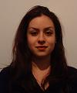

Eser Adiguzel, PhD, Department of Laboratory Medicine & Pathobiology (Supervisor: Dr. M. Bendeck): “The Role of Type VIII Collagen in Vascular Occlusive Disease”
(Research & Development Manager – Industry)

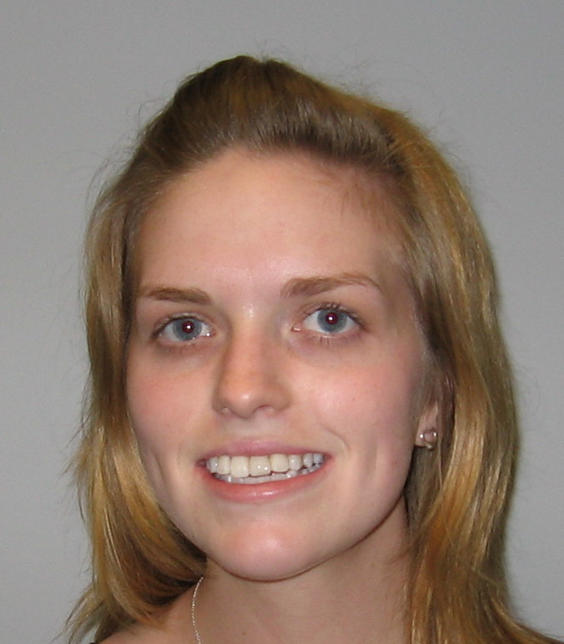
Laura Banks, MSc, Department of Exercise Sciences (Supervisor: Dr. J. Goodman): “Left and Right Ventricular Function Following Prolonged Exercise at Moderate and High Intensity in Healthy Young Recreational Athletes”
(PhD – University of Toronto)

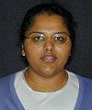

Shathiyah Kulandavelu, PhD, Department of Physiology (Supervisor: Dr. L. Adamson): “Cardiovascular, Utero- and Fetoplacental Function in Mice During Normal Pregnancy and in the Absence of Endothelial Nitric Oxide Synthase (eNOS)”
(Post-Doctoral Fellowship)

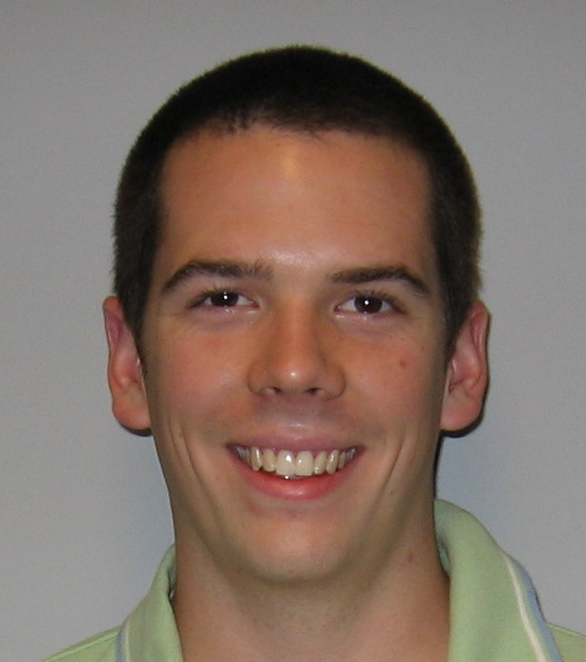

Shawn Lacombe, MSc, Department of Exercise Sciences (Supervisor: Dr. S. Thomas): “Interval and Continuous Exercise Elicit Equivalent Post-Exercise Hypotension Despite Differences in Baroreflex Sensitivity and Heart Rate Variability”

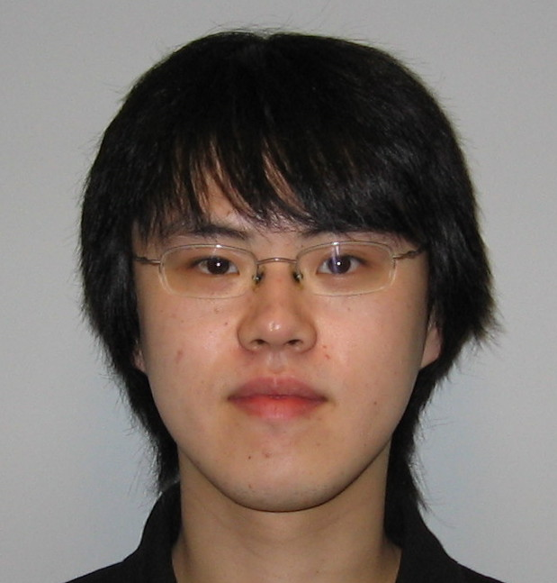
Mark Moon, MSc, Department of Physiology (Supervisor: Dr. P. Liu): “The Role of Mindin, a Member of the Mindin-F-Spondin Family, in Immune Responses and Cardiac Remodeling Post Myocardial Infarction”
(PhD – University of Toronto)

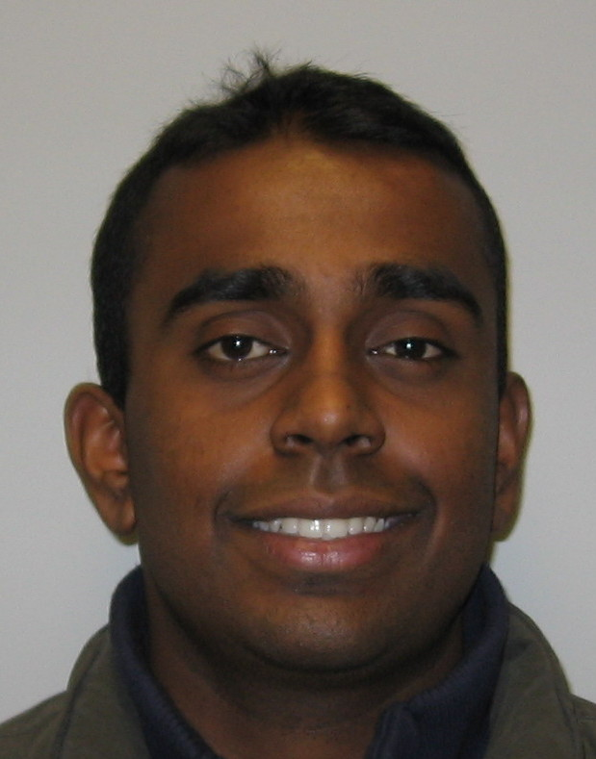

Kumar Perampaladas, MSc, Department of Pharmacology (Supervisor: Dr. J. Parker): “Effects of Rosiglitazone in a Nitroglycerin-Induced Model of Endothelial Dysfunction”
(Unknown)

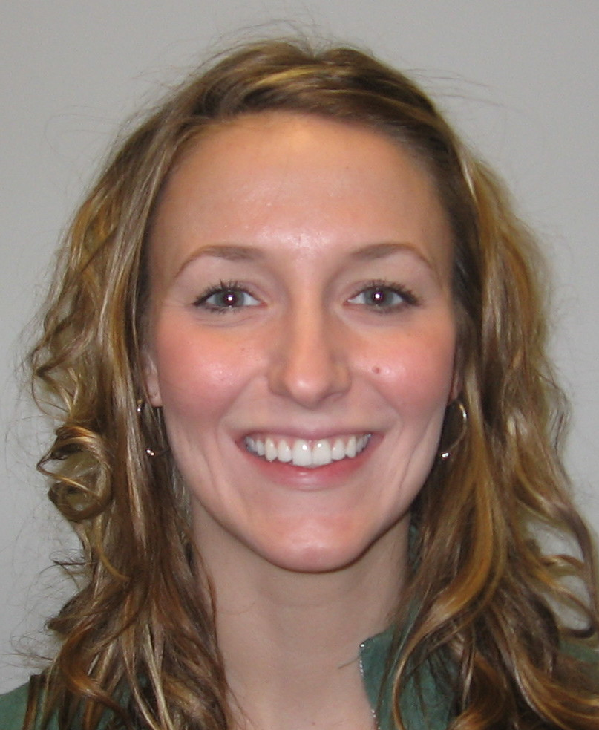

Meghan Sauvé, MSc, Institute of Medical Science (Supervisor: Dr. D. Drucker): “Genetic Elimination or Partial Selective Inhibition of DPP-4 Activity and Outcomes Following Experimental Ischemic Cardiac Injury in the Mouse”
(PhD – University of Toronto)

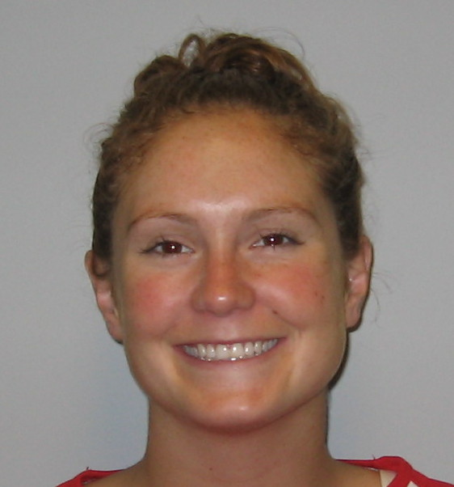

Carly Spragg, MSc, Department of Exercise Science (Supervisor: Dr. S. Thomas): “Post Exercise Hypotension and Blood Pressure Circadian Rhythm in Pre-Hypertensive Older Adults”
(Nursing, University of Toronto)

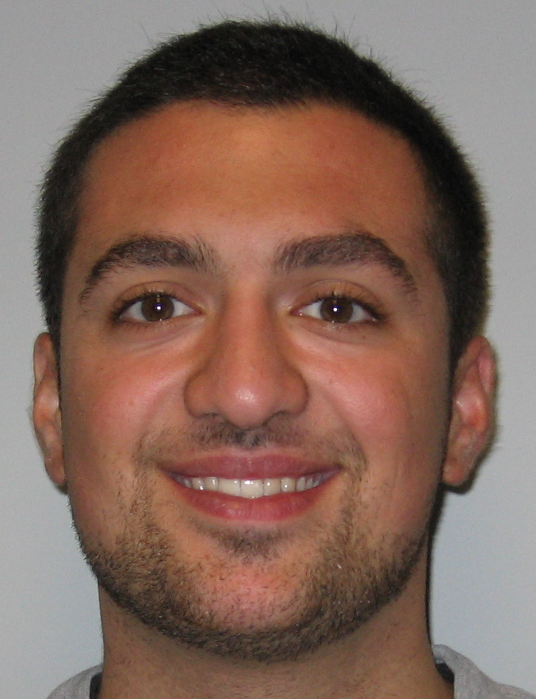

Sam Tirgari, MSc, Department of Physiology (Supervisor: Dr. S. Heximer): “Characterizing the Role of RGS5 in the Regulation of Vascular Smooth Muscle Cell Function”
(Medical School)

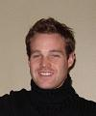Michael R. Ward, PhD, Institute of Medical Science (Supervisor: Dr. D. Stewart): “Gene Therapy for Endothelial Progenitor Cell Dysfunction”
(Medical School – Cardiology Clinician/Researcher)

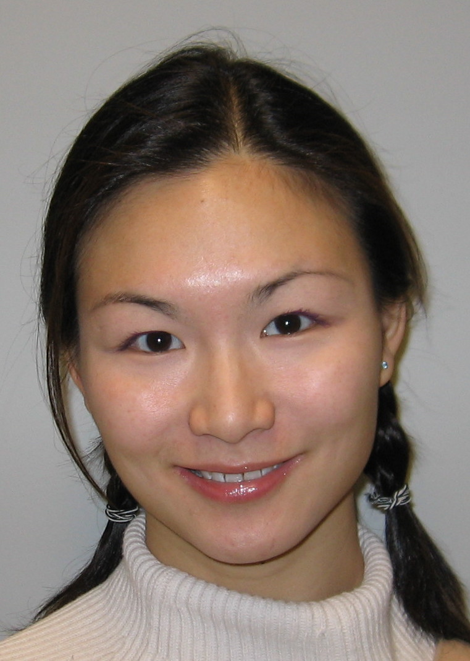Cindy Yip, PhD, Institute of Biomaterials and Biomedical Engineering (Supervisor: Dr. C. Simmons): “Pathology of Calcific Aortic Valve Disease: The Role of Mechanical and Biochemical Stimuli in Modulating the Phenotype of and Calcification by Valvular Interstitial Cells”
(Research & Development, Biotech Industry)

Note: Should discrepancy arise between total number of students enrolled and the number convocated, it can be accounted for students that are incomplete or terminate graduate studies.

AWARDS AND HONORS

NAME | HONORS AND AWARDS
Jenna Adleman | - Open Fellowship, Medical Sciences (Ophthalmology), University of  Toronto  - Vision Science Research Program, Medical Sciences (Ophthalmology),  UofT
Katherine Allan | - Open Fellowship, University of Toronto
Mitesh Badiwala | - Gallie-Bateman Award 2nd Prize, Dept. of Surgery, UofT, 2010
Laura Banks | - CIHR Doctoral Canadian Graduate Scholarship, Government of Canada,  2010-2013  - Doctoral Research Award, Heart & Stroke Foundation of Canada,  (declined) 2010-2013  - Ontario Graduate Scholarship, Government of Ontario (declined)  - Innovation Fund (grant), Labatt Family heart Centre, Hospital for Sick  Children, 2010-2011  - IMS Entry Award, Institute of Medical Science, UofT, 2009-2010
Mark Blaser | - Ontario Graduate Scholarship, 2010  - Barbara & Frank Milligan Graduate Fellowship, UofT, 2010  - Open Fellowship, UofT, 2010
Carlo Cifelli | - American Society for Biochemistry and Molecular Biology – Experimental  Biology 2010 Travel Award  - Bigelow Book Prize, CSCP, UofT, 2010
Geoffrey de Couto | - Medtronic Traval Award, CSCP, UofT, 2009
Kaveesh Dissanayake | - American Society for Biochemistry and Biology Travel Award, 2010  - HSRLCE Studentship Award, UofT, 2009-2010
Mostafa El Beheiry | - A.C. Bryan Award, Shields Research Day, 2010  - Frontiers in Physiology Research Day 1st Place Poster Award, Dept. of  Physiology, UofT, 2010
Joe Gabriel | - IMS Entrance Scholarship, UofT, 2009  - 1st Place, “University of Toronto Got Talent” Show Fundraiser, 2010
Arash Ghashghai | - Open Fellowship, UofT, 2009  - Frederick Banting and Charles Best Canada Graduate Scholarship –  Master’s Award, CIHR, 2009  - UofT Advanced Planning for Students Award, 2010
June Guo | - Banting and Best Diabetes Centre Graduate Scholarship, UofT,  2009-2010  - OGSST Fellowship, UofT, 2009-2010  - Medtronic Travel Award, CSCP, UofT, 2010  - Banting & Best Biabetes Centre Trainee Travel Award, UofT, 2010  - Canadian Diabetes Assoc. Doctoral Student Research Award, 2010-2013
Jemy Joseph | - University Health Network CREDIT Travel Award, 2009  - Post-Graduate Scholarship, NSERC, 2008-2010
Shazareen Khan | - Dr. Terry Kavanagh Fellowship, UofT, 2009
Jeffrey Kroetsch | - Doctoral Graduate Scholarship, NSERC, 2008-2010  - Corning Excellence in Microfluidics Research Award, 2nd Pl-Oral, 2010  - HSRLCE Conference, 2nd Pl-Poster, 2010  - Frontiers in Physiology Conference, 2nd Pl-Poster, 2010
Robert Lakin | - Glen Carter Fellowship, UofT, 2009
Matthew Machina | - 10th Annual Research Day in Respirology, 1st Pl-Poster, UofT, 2010
Anton Mihic | - Canadian Cardiovascular Congress Bursary Program, 2009  - Open Fellowship, UofT, 2009
Mark Moon | - Alan Wu Research Prize, 2010  - IMS Entrance Scholarship, UofT, 2010  - American Heart Association BCVS Abstract Travel Grant, 2009  - Heart Failure Society of American Travel Award, 2009
Melissa Noronha | - HSRLCE Conference, 3rd Pl-Poster, 2010  - HSRLCE Studentship Award, 2009-10  - HUPO Student Travel Award, 2009  - Fellowship, Dept. of Physiology, UofT, 2009
Andrew Ramadeen | - Best Presentation Award, CSCP Student Day, UofT, 2010  - Ontario Graduate Scholarship, 2009  - Entrance Fellowship Award, UofT, 2009
Anna Rosen | - HSFO Master’s Studentship, 2009-2010  - Best Presentation Award, CSCP Student Day, UofT, 2010  - Frontiers in Physiology, 1st Pl-Oral, UofT, 2010  - Dr. John Hepburn Memorial Award, 2010
Sanjana Sen | - Lawrence Becker Symposium,1st Pl-Poster, Hosp for Sick Children, 2010
Junyan Shi | - Lawrence Becker Symposium, 3rd Pl-Poster, Hosp for Sick Children, 2010  - OGSST, CSCP, UofT, 2009-2010  - UofT Entrance Award, 2009
Luke Tan | - Gordon Cressy Student Leadership Award, UofT, 2010

PUBLICATIONS
Badiwala MV, Ramzy D, Tumiati LC, Tepperman ED, Sheshgiri R, Prodger J, Feindel CM, Rao V: Response to letter regarding article, “Donor pretreatment with hypertonic saline attenuates primary allograft dysfunction: A pilot study in a porcine model”. Circulation, 2010;121:E394.

Badiwala MV, Verma S, Rao V: Surgical management of ischemic mitral regurgitation. Circulation, 2009;120:1287-93.

Badiwala MV, Ramzy D, Tumiati LC, Tepperman ED, Sheshgiri R, Prodger J, Feindel CM, Rao V: Donor pretreatment with hypertonic saline attenuates primary allograft dysfunction. Circulation, 2009-120:S206-14.

Ban K, Hus S, Drucker D, Husain M: Cardiovascular consequences of drugs used for the treatment of diabetes: Potential promise of incretin-based therapies. J Am Soc Hyperten, 2009;3(4):245-59. [Epub 2009 Jun]

Banks L, Sasson Z, Busato M, Goodman JM: Impaired left and right ventricular function following prolonged exercise in young, trained athletes: Influence of exercise intensity and response to dobutamine stress. J Appl Physiol, 2010;108(1):112-9.

Breen DM, Dhaliwall JK, Chan KK, Guo J, Lam L, Bendeck MP, Giacca A: Insulin inhibits and oral sucrose increases neointimal growth after artieal injury in rats. J Vasc Res, 2010;47(5):412-22.

Briet F, Mazer CD, Tsui AK, Zhang H, Khang J, Pang V, Baker AJ, Hare GM: Cerebral cortical gene expression in acutely anemic rats: A microarray analysis. Can J Anesth, 2009;56(12):921-34.

Brooks SC, Allan KS, Welsford M, Verbeek PR, O’Donnell C, Arntz HR, Morrison LJ: A systematic review and metaanalysis of prehospital triage and diversion for patients with ST elevation myocardial infarction directly to percutaneous coronary intervention centres: Are emergency medical services jumping the gun? CJEM, 2009;11(5):481-92.

de Couto G, Ouzounian M, Liu PP: Early detection of myocardial dysfunction and heart failure. Nat Rev Cardiol, 2010;7(6):334-44.

Gabriel JM: Historical changes in perspective of the etiology, pathophysiology and treatment of obstructive sleep apnea, Univ Toronto Med J, 2010;87(3):177-80.

Hui S, Brunt KR, Husain M: Temporal and spatial regulation of histone deacetylase-7 and β-catenin in endothelial cells. Circ Res, 2010;106:1180-83.

Kulkarni AV, Hui S, Shams I, Donnelly R: Quality of life in obstructive hydrocephalus: Endoscopic third ventriculostomy compared to cerebrospinal fluid shunt. Childs Nerv Syst, 2010;26(1):75-9. [Epub 2009 Aug]

Levy AS, Chung JCS, Kroetsch JT, Rush JWE: Nitric oxide and coronary vascular endothelium adaptations in hypertension. Vasc Health Risk Management, 2009;5:1075-87.

Lewis E, Banks L: To drink or not to drink: The effect of fluid replacement on post-exercise cardiovascular haemodynamics. J Physiol, 2010;558(1):27-8.

Lidington D, Peter BF, Meissner A, Kroetsch JT, Pitson SM, PohlU, Bolz S-S: The phosphorylation motif at serine 225 governs the localization and function of sphingosine kinase 1 in resistance arteries. Atheroscler Thromb Vasc Biol, 2009;29:1916-22.

MacIver J, Ross HJ, Delgado DH, Cusimano RJ, Yau TM, Rodger M, Harwood S, Rao V: Community support of patients with a left ventricular assist device. Can J Cardiol, 2009;25(11):e377-e381.

MacIver J, Ross HJ: Withdrawal of ventricular assist devise support. IN: Handbook on Palliative Care in the Intensive Care Unit, (Eds: Rocker G, Nelson J). Oxford University Press, 2010.

Maekawa Y, Mizue N, Chan A…de Couto, G, et al: Survival and cardiac remodeling after myocardial infarction are critically dependent on the host innate immune interleukin receptor-associated kinase-4 signaling: A regulator of bone marrow-derived dendtritic cells. Circulation, 2009;120(14):1401-14.

Morrison LJ, Verbeek PR, Zhan C, Kiss A, Allan KS: A universal termination of resuscitation clinical prediction rule for both advanced and basic life support providers. Resuscitation, 2009;80(3):324-8.

Ramadeen A, Laurent G, dos Santos CC, Hu X, Connelly KA, Holub BJ, Mangat I, Dorian P: n-3 polyunsaturated fatty acids alter expression of fibrotic and hypertropic genes in a dog model of atrial cardiomyopathy. Heart Rhythm, 2010;7:520-28.

Tepperman E, Ramzy D, Prodger J, Sheshgiri R, Badiwala MV, Ross H, Rao V: Surgical biology for the clinicial: Vascular effects of immunosuppression. Can J Surg, 2010;53:57-63.

FACULTY

Faculty are divided into 3 categories (Full, Associate, Affiliate). Details on faculty research interests, and contact information are available on the CSCP web site. Departmental affiliations listed below are those within the CSCP. For annual information on faculty peer-reviewed funding and publications, please refer to their home department’s annual reports.

Name Departmental Affiliation(s) Location

Full
Lee Adamson BME/IMS/PSL Mount Sinai Hospital
Khosrow Adeli LMP Hospital for Sick Children
Peter Backx Medicine/PSL UofT – FitzGerald Bldg.
Jaques Belik IMS/PSL Hospital for Sick Children
Michelle Bendeck LMP/Medicine UofT – MSB
Sandra Black IMS Sunnybrook Health Centre
Douglas Bradley IMS/Medicine Toronto General Hospital
Dina Brooks REH UofT – Rehabilitation
Science
Sean Clarke NUR UofT – Faculty of Nursing
John Coles IMS/Surgery Hospital for Sick Children
Philip Connelly LMP/Medicine St. Michael’s Hospital
David Courtman BME/Surgery St. Michael’s Hospital
Paul Dorian IMS/Medicine/PCL St. Michael’s Hospital
Daniel Drucker IMS/LMP Mount Sinai Hospital
Joel Fisher Anesthesia Toronto General Hospital
John Flanagan IMS Toronto Western Hospital
John S. Floras IMS/Medicine Mount Sinai Hospital
Stephen Fremes IMS/Surgery Sunnybrook Health Centre
Adria Giacca PSL UofT - MSB
Jack M. Goodman EXS UofT - Physical Ed & Health
Len S. Goodman EXS Def & Civil Inst Environ Med
Avrum I. Gotlieb LMP Toronto General Hospital
David Hampson Pharmaceutical Science UofT – Pharmacy
Gregory Hare PSL St. Michael’s Hospital
Scott Heximer PSL UofT - MSB
Aleksander Hinek IMS/LMP Hospital for Sick Children
Margaret Hough IMS Sunnybrook Health Centre
Chris Hudson IMS Toronto Western Hospital
Mansoor Husain IMS/LMP/Medicine Toronto General Hospital
K. Wayne Johnston BME/IMS/Surgery Toronto General Hospital
Peter G. Kalman IMS/Surgery Community
Armand Keating IMS/BME Princess Margaret Hospital
Michelle Letarte MBP Hospital for Sick Children
Gary F. Lewis IMS/Medicine Toronto General Hospital
Ren-Ke Li IMS/LMP/Surgery Toronto General Hospital
Tom Lindsay IMS/Surgery Toronto General Hospital
Peter Liu IMS/Medicine Toronto General Hospital
Marius Locke EXS/CHL UofT – Physical Ed & Health
Philip Marsden IMS/LMP/MBP/Medicine UofT – MSB
Brian McCrindle IMS/HPME Hospital for Sick Children
Peter McLaughlin IMS/Medicine Toronto General Hospital
Alan Moody BME/IMS Sunnybrook Health Centre
David Naylor IMS/Medicine/CHL/Surgery UofT – MSB
Heyu Ni LMP St. Michael’s Hospital
Peter O’Brien PHM UofT - Pharmacy
John Parker IMS/Medicine Mount Sinai Hospital
Tom Parker IMS/Medicine Toronto General Hospital
Margaret Rand IMS/LMP Hospital for Sick Children
Vivek Rao IMS/Surgery Toronto General Hospital
Michael Sefton BME UofT – Wallberg Bldg.
Craig Simmons BME UofT – Mech. Engineering
Arthur S. Slutsky IMS/Medicine/Surgery Mount Sinai Hospital
David Steinman BME UofT – Wallberg Bldg.
Donna E. Stewart Anesthesia/IMS/Surgery/Medicine Toronto General Hospital
Duncan Stewart IMS/LMP/Medicine St. Michael’s Hospital
Bradley Strauss LMP/Medicine St. Michael’s Hospital
Howard Tenenbaum Dentistry UofT - Dentistry
Scott G. Thomas EXS/PSL UofT – Physical Ed & Health
Jack Tu HPME Sunnybrook Health Centre
Michael Tymianski IMS/PSL Toronto Western Hospital
Robert Wald IMS/Medicine Mount Sinai Hospital
Richard D. Weisel IMS/Surgery Toronto General Hospital
Peter Wells PHM UofT - Pharmacy
Gregory Wilson IMS/LMP/PSL/Surgery Toronto General Hospital
Carin Wittnich IMS/PSL/Surgery UofT - MSB
Graham Wright MBP Sunnybrook Health Centre
Shirley Wu PHM UofT - Pharmacy
Burton Yang LMP Sunnybrook Health Centre
Terry Yau IMS/Surgery Toronto General Hospital
Erik L. Yeo IMS/Medicine Toronto General Hospital
Yeni Yücel LMP St. Michael’s Hospital
Haibo Zhang IMS/PSL St. Michael’s Hospital

Associate
Gil Gross IMS Hospital for Sick Children
William Hutchison PSL Toronto Western Hospital
Jane Irvine CHL Toronto General Hospital
Howard Leong-Poi IMS St. Michael’s Hospital
Valery Leytin LMP St. Michael’s Hospital
David Mazer Anesthesia/IMS St. Michael’s Hospital
Seema Mital IMS Hospital for Sick Children
Kumar Nanthakumar IMS Toronto General Hospital
Steffen-Sebastian Bolz PSL UofT – MSB
Anthony Gramolini PSL UofT – Best Institute
Vijay Chauhan IMS/Medicine/PSL Toronto General Hospital

Affiliate
Jagdish Butany LMP/Medicine Toronto General Hospital
Gideon Cohen Surgery Sunnybrook Health Centre

Faculty publications for the 2008-2009 academic year can be found through their departmental websites.

